# Project Design Phase-Il Data Flow Diagram & User Stories

|  |  |
| --- | --- |
| Date | 05 October 2022 |
| Team ID | PNT2022TMID08727 |
| Project Name | IOT Based Crop Protection System for Agriculture |
| Maximum Marks | 4 Marks |

Data Flow Diagrams:

A Data Flow Diagram (DFD) is a traditional visual representation of the information flows within a system. A neat and clear DFD can depict the right amount of the system requirement graphically. It shows how data enters and leaves the system, what changes the information, and where data is stored.

Example:

|  |  |  |  |  |  |  |
| --- | --- | --- | --- | --- | --- | --- |
| User Type | Functional  Requirement  (Epic) | User Story Number | User Story I Task | Acceptance criteria | Priority | Release |
| Customer  (Mobile user) | Registration | USN-I | As a user, I can register for the application by entering my email, password, and confirming my password. | I can access my account / dashboard | High | Sprint-I |
|  |  | USN-2 | As a user, I will receive confirmation email once I have registered for the application | I can receive confirmation email & click confirm | High | Sprint-I |
|  |  | USN-3 | As a user, I can register for the application through Facebook | I can register & access the dashboard with Facebook | Low | Sprint-2 |

Flow

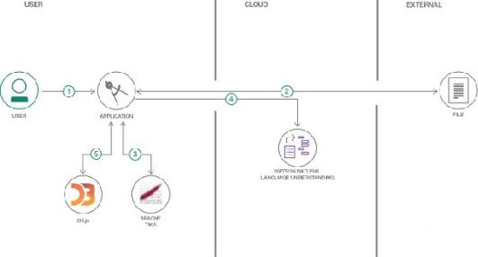

1. User configures credentials for the Watson Natural Language Understanding service and starts the app.
2. User selects data file to process and load.
3. Apache Tika extracts text from the data file.
4. Extracted text is passed to Watson NLU for enrichment.
5. Enriched data is visualized in the I-JI using the D3.js library.

## User Stories

Use the below template to list all the user stories for the product.

|  |  |  |  |  |  |  |
| --- | --- | --- | --- | --- | --- | --- |
| User Type | Functional  Requirement  (Epic) | User Story Number | User Story I Task | Acceptance criteria | Priority | Release |
|  |  | USN-4 | As a user, I can register for the application through Gmail | I can increase or decrease weather | Medium | Sprint-I |
|  |  | USN-5 | As a user, I can log into the application by entering email & password | I can access my weather status ahead in my field | High | Sprint-I |
|  | Dashboard | USN-6 | As a user, I can log into the open weather map by entering email & password | I can access the application through my Gmail login |  | Spint-2 |
| Customer (Web user) | Interface | USN-7 | As a user the interface should be simple and easily accessible | I can access the interface easily | Hligh | Spint-l |
| Customer Care Executive | Data generation | USN-8 | As a user open weather application to access the data regarding the weather changes | I can access the data regarding the weather through the application |  | Spint-l |
| Administrator | Problem Solving/  Fault clearance | USN-9 | As an official who is in charge for the proper fumnctioning of the sign boards have to maintain it through periodic monitoring. | Officials can monitor the sign boards for proper functioning | Medium | Spint-2 |